Project Overview
For this project, I developed a web-based dashboard for Grazioso Salvare that allows users to filter and review animal shelter outcome data stored in MongoDB. The goal was to create something interactive, clear, and easy to use while following the MVC design pattern introduced in the course.
MongoDB serves as the model, Dash provides the view, and the Python callback functions act as the controller, connecting user selections to database queries and visual updates.
- The completed dashboard includes:
  - Four filtering options:
    - Water Rescue
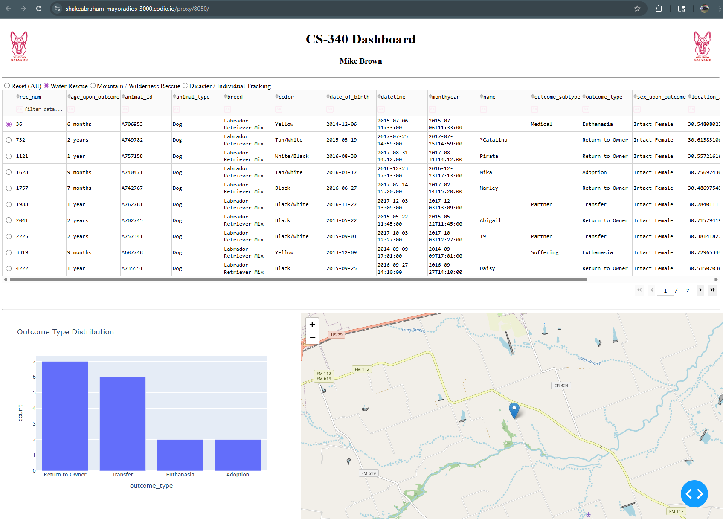

    - Mountain or Wilderness Rescue
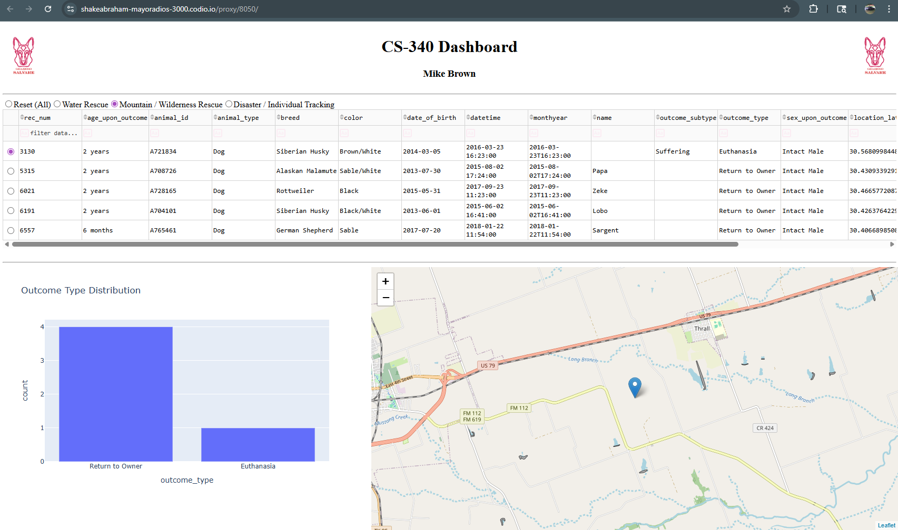
    - Disaster or Individual Tracking
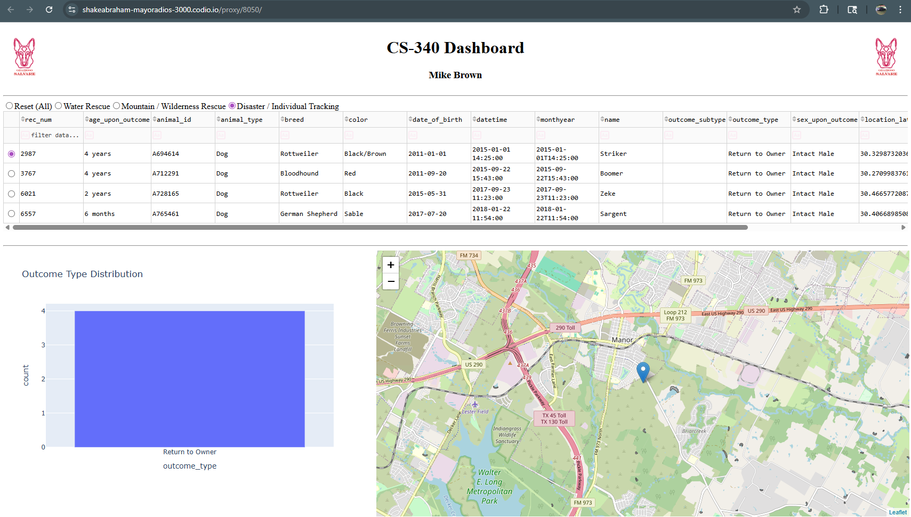

    - Reset (unfiltered view)
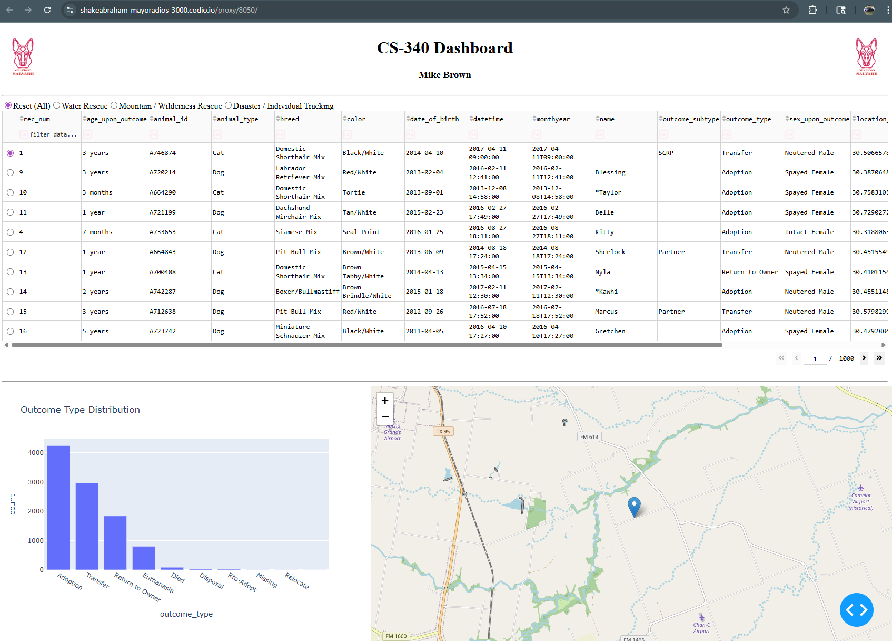
- A dynamic data table that updates when a filter is selected
- A geolocation map that recenters and zooms based on the selected animal
- A bar chart that displays outcome type distribution
- Grazioso Salvare branding and my unique identifier
The data table supports sorting, filtering, pagination, and row selection. When a user selects a row, the map automatically recenters on that animal’s coordinates. Screenshots included in this document show the initial state and each filter scenario to demonstrate that all components update properly.

Tools Used and Why
I used MongoDB as the database because it stores information in a document format that closely resembles JSON. This made it a natural fit for the shelter dataset. MongoDB’s flexible schema and powerful query operators (such as $in, $gte, and $lte) made filtering by breed, age, and sex straightforward. It also integrates easily with Python through PyMongo.
Python was used as the main programming language because of its readability and strong data-processing libraries.
Dash (Plotly) was used to build the dashboard interface. Dash makes it easy to create interactive web components and link them together using callback functions. It allowed the filters, table, chart, and map to update automatically when a user selects.
Pandas helped convert MongoDB query results into DataFrames, making it easier to clean the data and prepare it for visualization.
Dash Leaflet was used to create interactive maps and handle geolocation features.

Steps I Took to Complete the Project
- Imported the Austin Animal Center dataset into MongoDB.
- Connected to the database using the CRUD module developed in Project One.
- Built the dashboard layout using JupyterDash.
- Added interactive filtering controls tied to MongoDB queries.
- Connected the filters to the data table, bar chart, and map using callbacks.
- Implemented dynamic map recentering based on row selection.
- Tested each rescue type filter and captured screenshots to confirm functionality.

Challenges and How I Resolved Them
One issue I ran into was MongoDB’s _id field causing errors in the Dash DataTable because it is returned as an ObjectId type. I resolved this by converting it to a string (or removing it) before rendering the table.
Another challenge involved latitude and longitude values being interpreted as strings, which caused errors when placing map markers. Converting those values to numeric types fixed the issue and allowed the map to recenter properly.
I also encountered a few callback scope and indentation errors early on. Restarting the kernel and restructuring the callback functions resolved those problems.

How to Reproduce This Project
- Ensure MongoDB is running with authentication enabled.
- Import the aac_shelter_outcomes.csv dataset into the aac database.
- Place ProjectTwoDashboard.ipynb and CRUD_Python_Module.py in the same folder.
- Install required libraries:
  - dash
  - jupyter-dash
  - dash-leaflet
  - pandas
  - plotly
- Update the MongoDB username and password in the notebook.
- Run all cells and interact with the filter options.

Resources Used
MongoDB Documentation: https://www.mongodb.com/docs/
Dash Documentation: https://dash.plotly.com/
Plotly Documentation: https://plotly.com/python/
PyMongo Documentation: https://pymongo.readthedocs.io/

